**EMTH1019 Linear Algebra & Statistics for Engineers**

# Week 4 Solutions

1. Firstly, note that it is assumed that, if many wire specimens were tested, therelative frequency distribution of UTS measurements would be nearly normal. A confidence interval based on the *t*-distribution can then be employed. With 1−*α* = 0*.*95 and *n*−1 = 4 degrees of freedom, *t*0*.*025 = 2*.*776. From the observed data, ¯*x* = 256*.*60 and *s* = 3*.*05. Thus, ¯ becomes 256*.*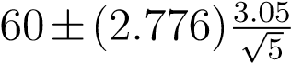

or 256*.*60 ± 3*.*79. Thus, we are 95% confident that the interval (252*.*81*,*260*.*39) includes the true mean UTS for the roll. Note that if we are not justified in making the assumption of normality for the population of tensile strengths, then we would be uncertain of the confidence level for this interval. The Central Limit Theorem would not help in this small-sample case.

1. Given information: *n* = 40, ¯*x* = 46, *s* = 3, *α* = 0*.*05. Since the population standard deviation is unknown, CI is given by $\overline{x}±t_{\frac{α}{2},n-1}\frac{s}{\sqrt{n}}$ , i.e. $46±2.023*\frac{3}{\sqrt{40}}$ Hence, the 95% CI is (45.04, 46.96).
2. The sample size is given by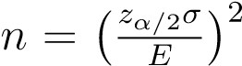, where *E* = 0*.*5 and *α* = 0*.*05. We are going to use an approximation for *σ*. In practice this is accomplished by taking a preliminary sample and using *s* to estimate *σ*, which is given to us in Question 2.

So, $n={\left(\frac{1.96*3}{0.5}\right)}^{2}=138.2976$ e, we take *n* = 139 as we always round up to stay on the conservative side of the estimate.

1. Given information: *n* = 5, $\overline{x}$ = 180, *s* = 5, *α* = 0*.*05. Since the population standard deviation is unknown, CI is given by ¯ $\overline{x}±t_{\frac{α}{2},n-1}\frac{s}{\sqrt{n}}$ i.e. 180 $±2.776*\frac{5}{\sqrt{5}}$.

Hence, the 95% CI is (173.793, 186.207). Because the sample size is very small, this may not ensure an approximately normal distribution for *X*¯, in this case we need to make the additional assumption that the random variable under study has a normal distribution, i.e. we need to make the assumption that the measurements for breaking strengths are normally distributed.

1. (a) Here *n* = 10, so the CI is given by ¯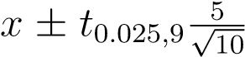 , where *t*0*.*025*,*9 = 2*.*262.

Therefore, the 95% CI is (176*.*423*,*183*.*577).

* 1. Here *n* = 100, so the sample size is large, i.e. the *t*-distribution will be very close to the normal distribution. Hence the 95% CI is given by ¯ , where *zα/*2 = *z*0*.*025 = 1*.*96, i.e. (179*.*02*,*180*.*98). Notice the effect sample size has on the confidence interval. As *n* increases the interval becomes more narrow.

1. The sample size is *n* = 9, ¯*x* = 550, *s* = 243*.*1414198 (remember to divide by *n*−1 and not by *n*), and *α* = 0*.*1. The 90% CI is then given by: 550±*t*0*.*1*/*2*,*8*243.141/ , where *t*0*.*05*,*8 = 1*.*860, i.e. (399*.*252*,*700*.*748)
2. Given information: *n* = 30, ¯*x* = 103, *σ* = 4, *α* = 0*.*01.

**Hypotheses**:

*H*0 : *µ* = 100

*HA* : *µ >* 100

**Test statistic:**

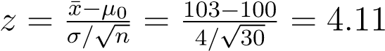

*p*-value = *P*(*Z >* 4*.*11) = 1 − *P*(*Z* ≤ 4*.*11) ≈ 0

**Decision:** *p*-value *< α* so reject *H*0.

**Conclusion:** At the 1% level of significance, there is sufficient evidence to suggest that average pressure exceeds 100 psi for a four-hour period.

1. Given information: *n* = 40, $\overline{x}$ = 128*.*6, *s* = 2*.*1, *α* = 0*.*05, *µ*0 = 130.

**Hypotheses**:

*H*0 : *µ* = 130

*HA* : *µ <* 130

**Test statistic:**

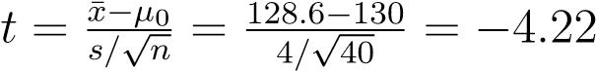

*p*-value = *P*(*T <* −4*.*22) = 1 − *P*(*T >* −4*.*22) = *P*(*T >* 4*.*22) ≈ 0 (by symmetry; and using 39 degrees of freedom)

**Decision:** *p*-value *< α* so reject *H*0.

**Conclusion:** At the 5% level of significance, there is sufficient evidence to suggest that the average output voltage is less than 130.

1. Given information: *n* = 50, $\overline{x}$ = 62, *s* = 8, *α* = 0*.*01, *µ*0 = 64. **Hypotheses**:

As the direction is not specified, we’ll assume that it is a two-tiled test.

*H*0 : *µ* = 64

*HA* : *µ* 6= 64

**Test statistic:**

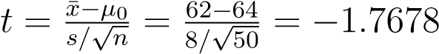

*p*-value = 2*P*(*T >* 1*.*7678). Since 1*.*677 *<* 1*.*7678 *<* 2*.*010, we can estimate the *p*-value as 2(0.025)*<p*-value*<*2(0.05), i.e. 0.05*< p*-value*<*0.1.

**Decision:** *p*-value *> α* so do not reject *H*0.

**Conclusion:** At the 1% level of significance, we have insufficient evidence to reject the manufacturer’s claim that this type of steel has an average hardness index of 64.

1. (a) Given information: *n* = 45, $\overline{x}$ = 2*.*667, *s* = 3*.*057, *α* = 0*.*025, *µ*0 = 3*.*6.

**Hypotheses**:

*H*0 : *µ* = 3*.*6

*HA* : *µ <* 3*.*6

**Test statistic:**

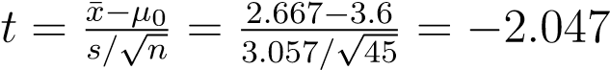

*p*-value = *P*(*T >* 2*.*047). Since 2*.*015 *<* 2*.*047 *<* 2*.*414, we can estimate the *p*-value as 0.01*<p*-value*<*0.025. **Decision:** *p*-value *< α* so reject *H*0.

**Conclusion:** At the 2.5% level of significance, there is sufficient evidence in the data to conclude that the number of unremovable defects is less than

3.6.

* 1. Type II error. The consequences of this error are that in reality the meannumber of unremovable defects is smaller than 3.6 which may be within an acceptable range. Anything above this may require additional expense to ensure that the product is of reasonable quality.

1. (a) Given information: *n* = 9, $\overline{x}$ = 114, *s* = 8*.*3367, *α* = 0*.*05, *µ*0 = 107.

**Hypotheses**: *H*0 H0: *µ* = 107

*HA* : *µ $≠$*  107

**Test statistic:**

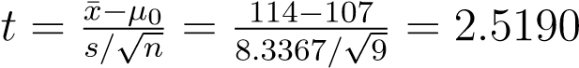

*p*-value = 2*P*(*T >* 2*.*5190). Since 2*.*306 *<* 2*.*5190 *<* 2*.*896, we can estimate the *p*-value as 0.02*<p*-value*<*0.05.

**Decision:** *p*-value *< α* so reject *H*0.

**Conclusion:** At the 5% level of significance, there is sufficient evidence in the data to conclude that the key performance indicator is different from 107.

* 1. Type I error. However, the risk of committing this error that we are willing to accept is quite small at 5%.

1. (a) Given information: *n* = 5, $\overline{x}$ = 14*.*4, *s* = 0*.*158114, *α* = 0*.*05, *µ*0 = 14. Note that we need to assume that the sample comes from a normal distribution due to small sample size.

**Hypotheses**:

*H*0 : *µ* = 14

*HA* : *µ $≠$* 14

**Test statistic:**

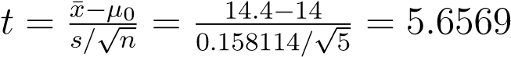

This is a two-sided test, so we’ll reject *H*0 if either *t <* −*tα/*2*,n*−1 or *t >*

*tα/*2*,n*−1. *tα/*2*,n*−1 = *t*0*.*025*,*4 = 2*.*776.

**Decision:** Clearly, the test statistic falls within the rejection region, so we reject *H*0. Alternatively, we could have found the *p*-value (0*.*002 *< p*-value *<* 0*.*01) to reach the same conclusion.

**Conclusion:** At the 5% level of significance, there is a statistically significant difference between the mean of the given sample and what is claimed by the manufacturer.

(b) If the first measurement is changed to 16.0 from 14.5, this will have an effect on the sample mean and sample standard deviation, i.e. ¯*x* = 14*.*7,

*s* = 0*.*741620. Notice that the standard deviation has increased substantially meaning that the test statistic will be substantially lower, i.e. *t* = 2*.*1106. It can be seen that this falls outside of the rejection region, therefore, now we would not have sufficient evidence to reject *H*0. This illustrates the pitfalls of using a small sample - a change in one value has a dramatic effect on the variability within the sample. In such a case, it would be advisable to collect another sample to see if the same conclusion can be reached.